7.13: a) The force is applied parallel to the ramp, and hence parallel to the oven’s motion, and so b) Because the applied force 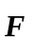 is parallel to the ramp, the normal force is just that needed to balance the component of the weight perpendicular to the ramp, 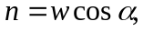 and so the friction force is 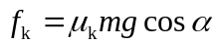 and the work done by friction is
keeping an extra figure. c) , again keeping an extra figure. d) e) In the direction up the ramp, the net force is
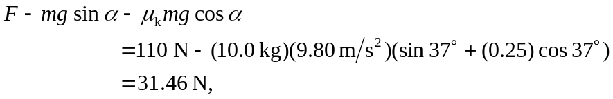
so the acceleration is 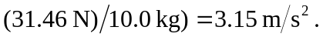 The speed after moving up the ramp is and the kinetic energy is 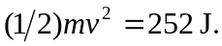 (In the above, numerical results of specific parts may differ in the third place if extra figures are not kept in the intermediate calculations.)

